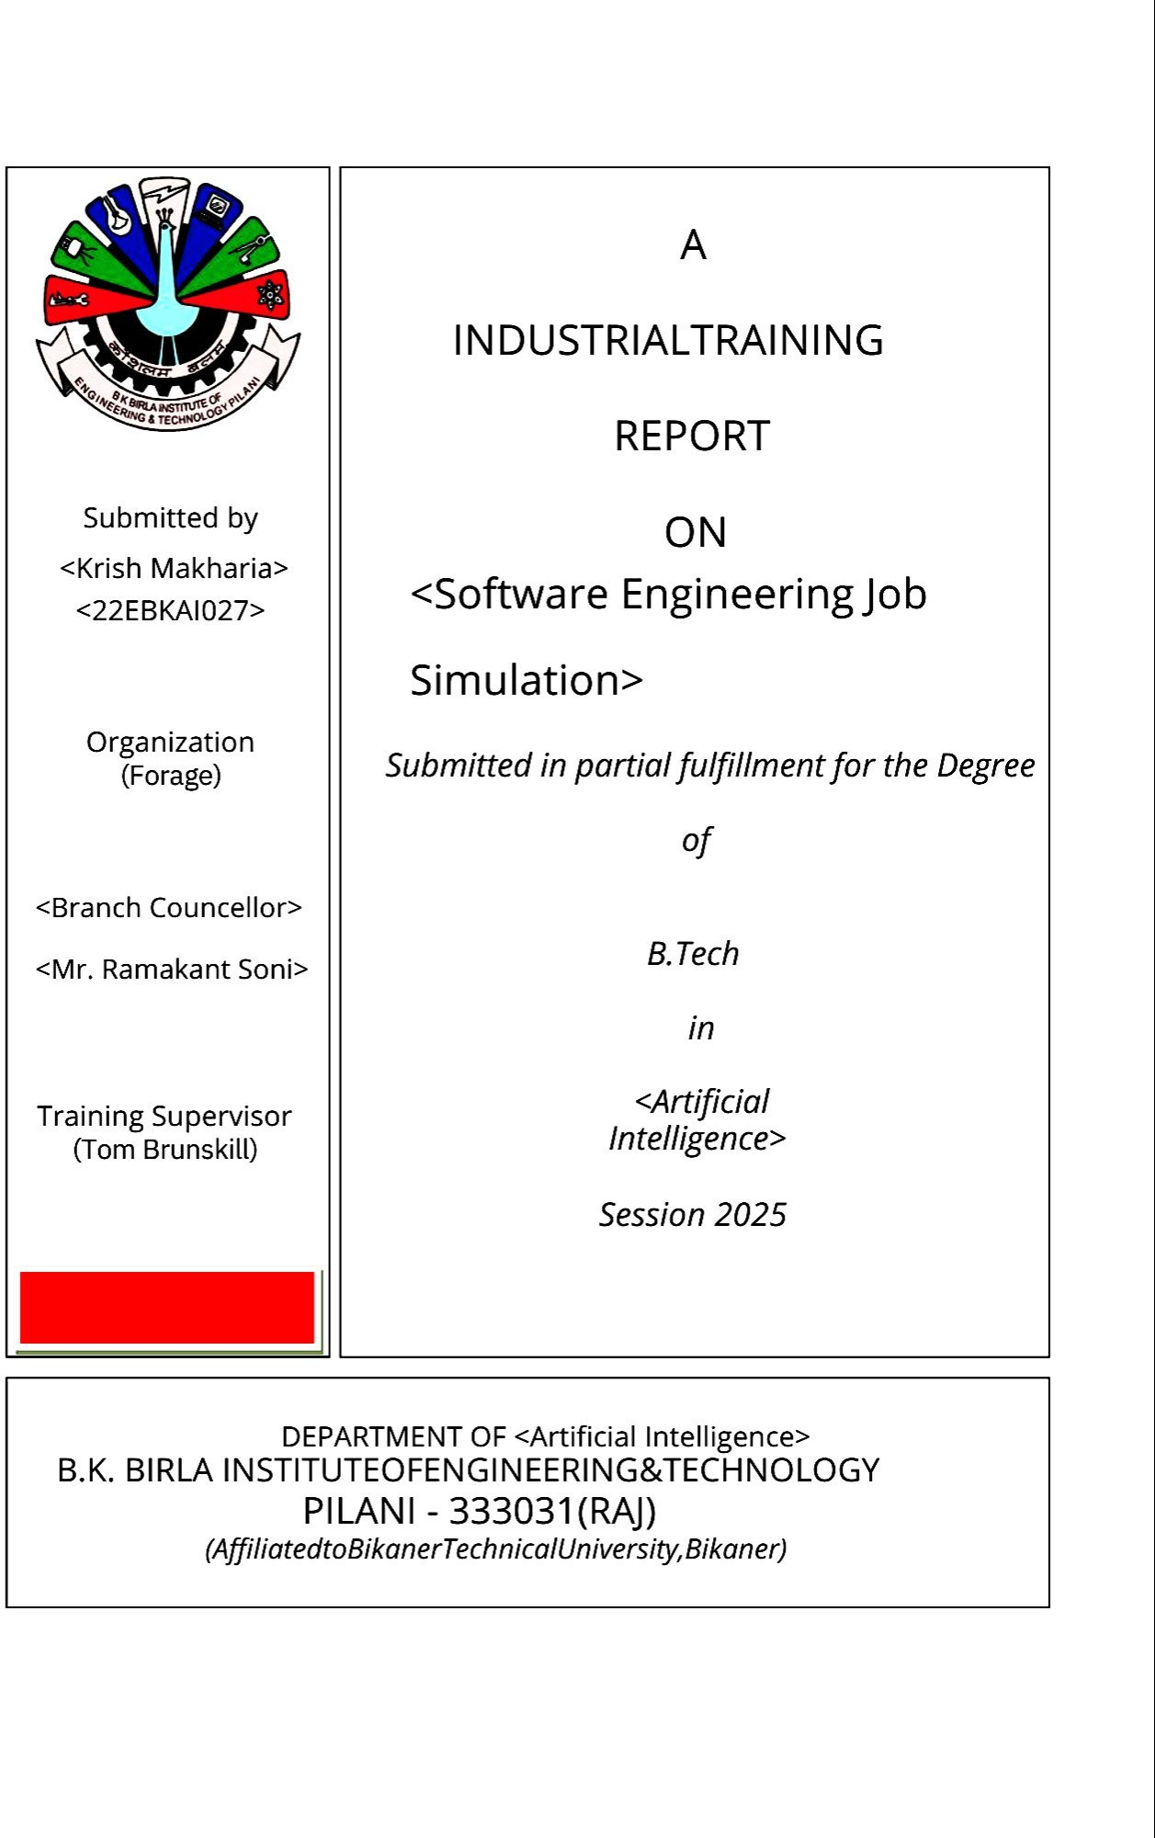
Department of Artificial Intelligence

Artificial Intelligence
Software Engineering Job Simulation
Tom Brunskill
Branch Counceller
Howlett Packard Enterprice (Forage)
Krish Makharia
22EBKAI027
Mr. Manoj Kumar Saini

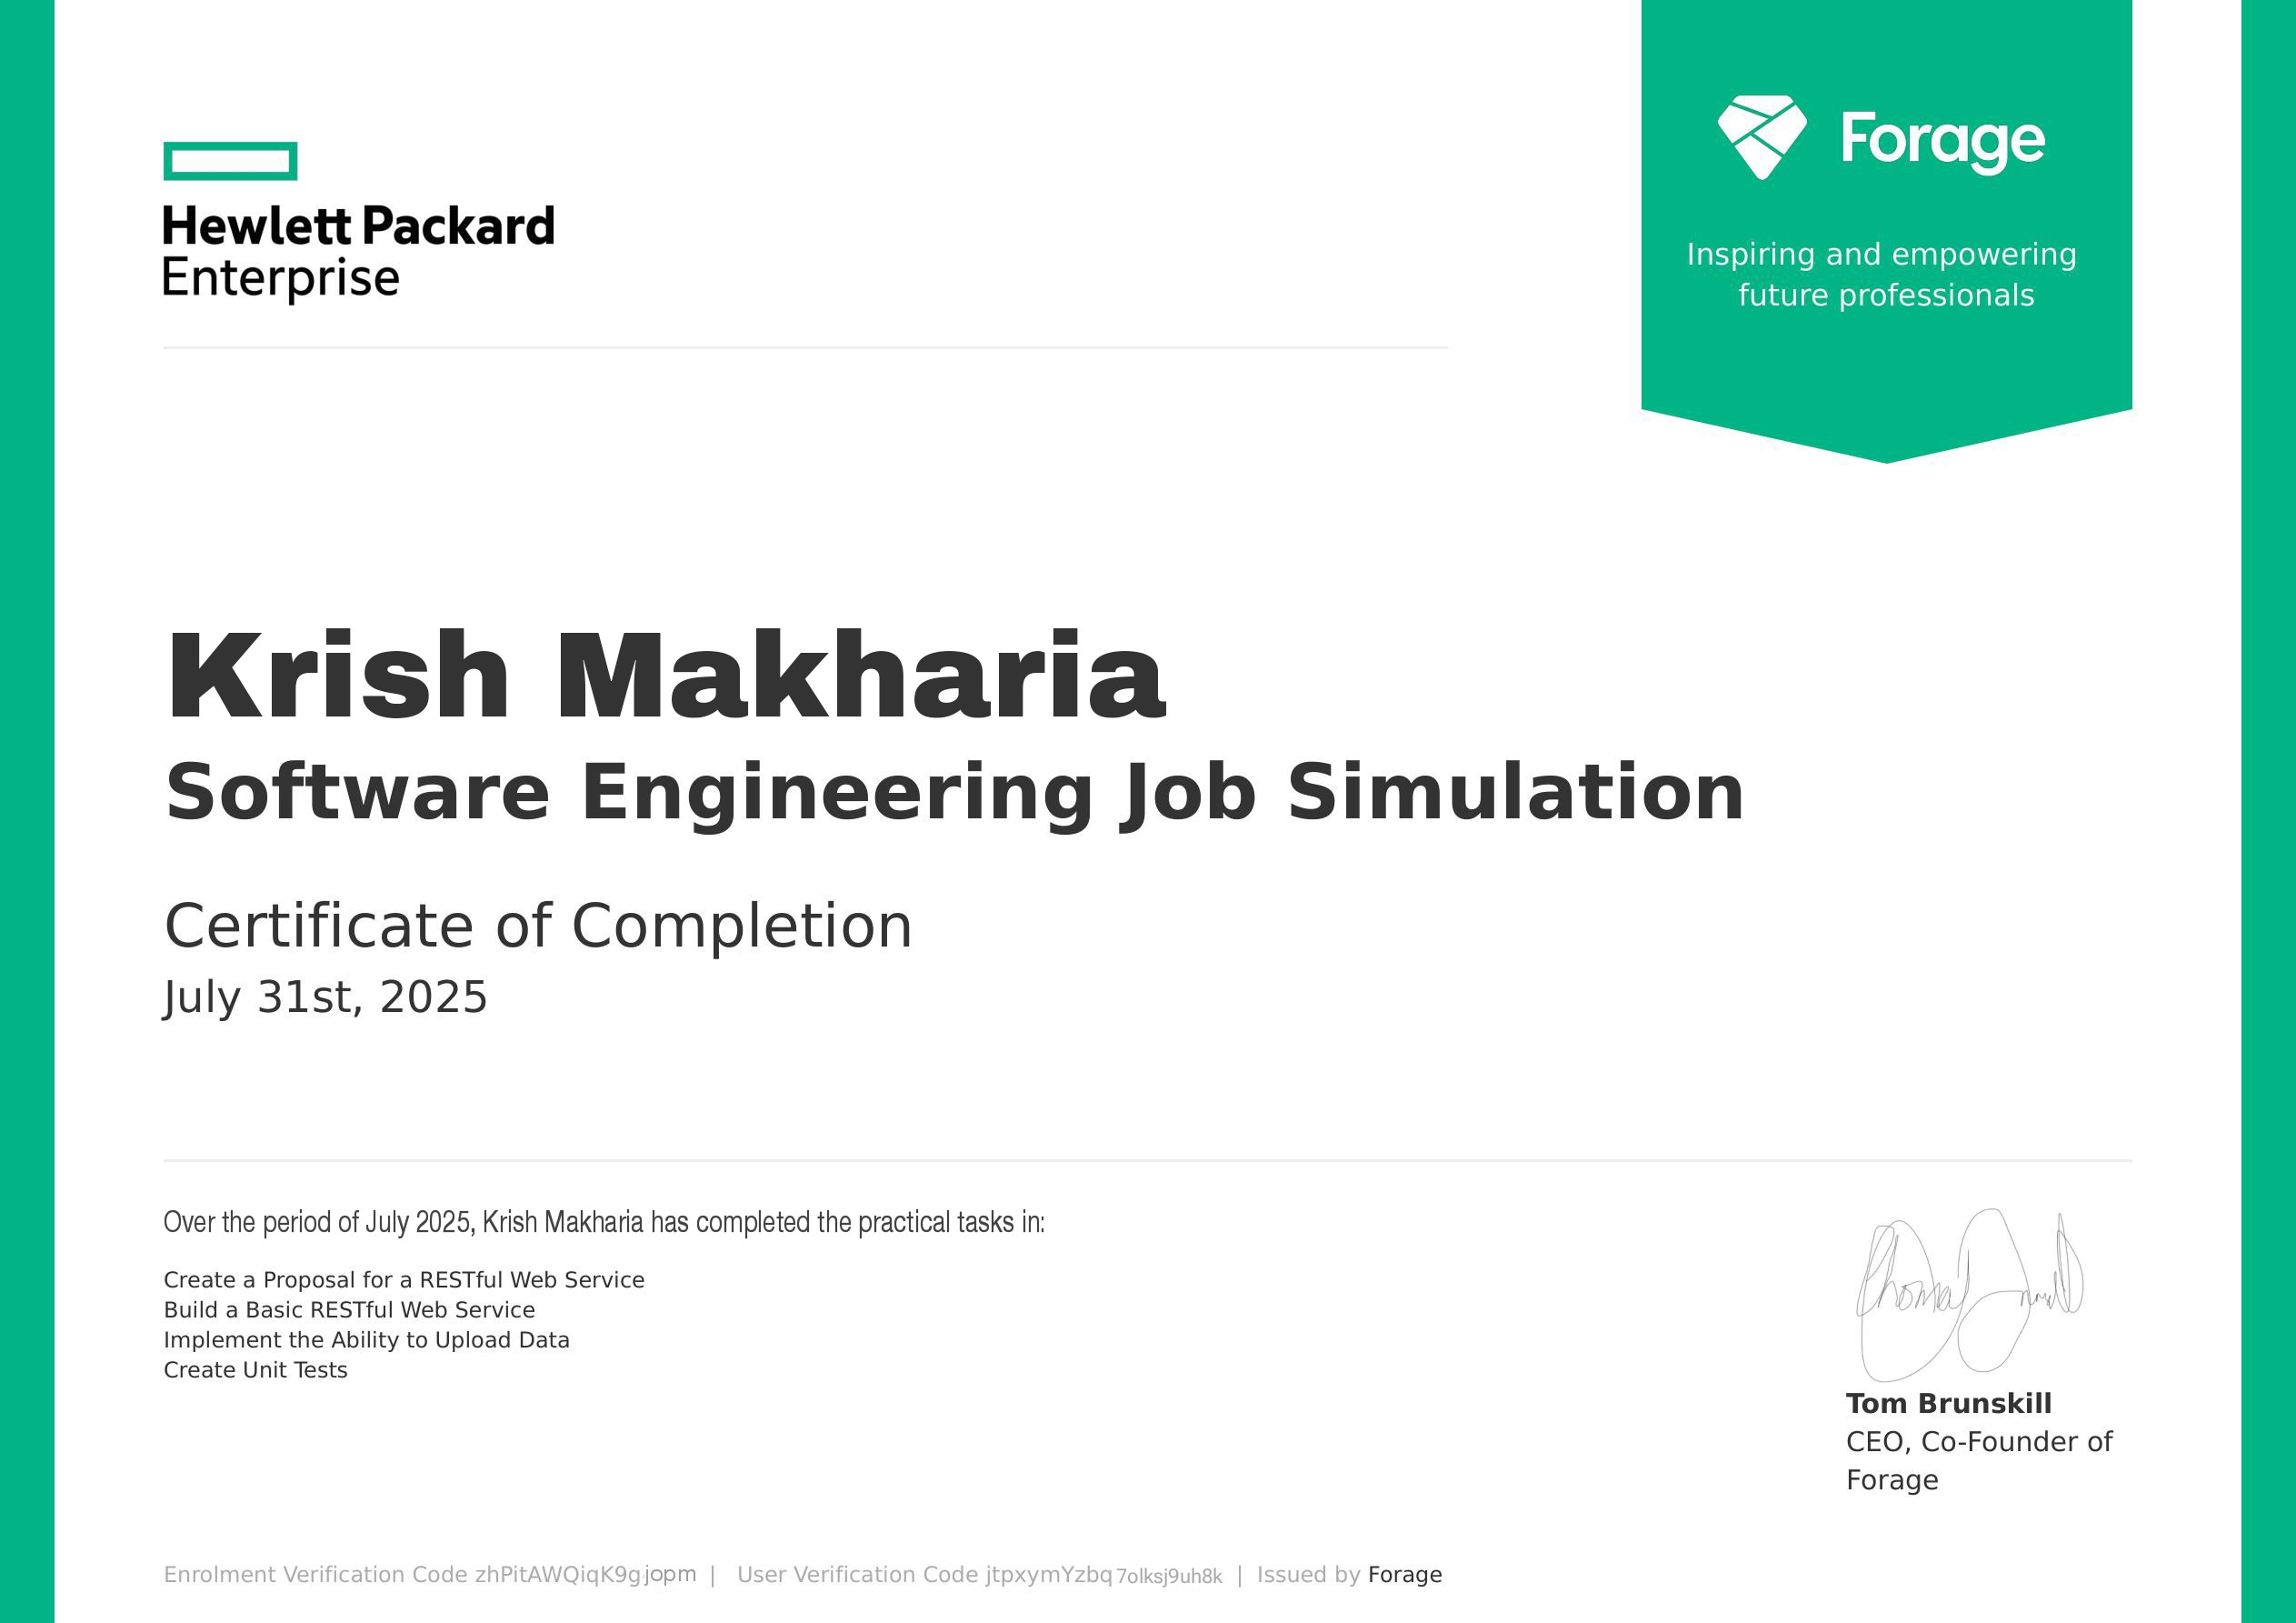

ACKNOWLEDGEMENT
I would like to extend my sincere gratitude to Forage for organizing and providing access to the Software Engineering Job Simulation. This program has been a valuable opportunity to gain hands-on experience in key aspects of backend software engineering, particularly in the design and implementation of RESTful web services and software testing practices.

My appreciation also goes to Tom Brunskill, CEO and Co-Founder of Forage, for his leadership in inspiring and empowering future professionals through accessible industry simulations. Finally, I am grateful for the encouragement of my peers and mentors, who have guided me in refining my skills and applying theoretical knowledge to practical, real-world tasks.

TABLE OF CONTENTS
- INTRODUCTION
- OBJECTIVES OF THE TRAINING PROJECT
- SCOPE AND DELIVERABLES
- TOOLS, TECHNOLOGIES AND ENVIRONMENT
- METHODOLOGY AND WORKFLOW
- MODULE 1: CREATE A PROPOSAL FOR A RESTFUL WEB SERVICE
  - 6.1 REST ARCHITECTURE PRINCIPLES
  - 6.2 RESOURCE MODELING AND DESIGN
  - 6.3 PROPOSAL DOCUMENT STRUCTURE
  - 6.4 SAMPLE PROPOSAL (EXCERPT)
- MODULE 2: BUILD A BASIC RESTFUL WEB SERVICE
  - 7.1 PROJECT STRUCTURE AND SETUP
  - 7.2 DETAILED IMPLEMENTATION (CODE SNIPPETS & EXPLANATION)
  - 7.3 ERROR HANDLING AND VALIDATION
  - 7.4 DEPLOYMENT NOTES
- MODULE 3: IMPLEMENT THE ABILITY TO UPLOAD DATA
  - 8.1 FILE UPLOAD ARCHITECTURE
  - 8.2 SECURITY AND VALIDATION STRATEGIES
  - 8.3 STORAGE STRATEGIES (LOCAL vs CLOUD)
- RESULT AND ANALYSIS
- CONCLUSION AND RELECTIONS
- REFERENCES

INTRODUCTION
This industrial training report documents the tasks completed and knowledge acquired during the Forage Software Engineering Job Simulation (July 2025). The training simulates
entry-level backend engineering responsibilities through four practical modules: API proposal, API implementation, file upload handling, and unit testing. The emphasis of this report is on demonstrating competency through documentation, technical explanation, and validated prototype work.

The simulation consisted of four modules:

- Proposing a RESTful Web Service,
- Building a Basic RESTful Web Service,
- Implementing the Ability to Upload Data, and
- Creating Unit Tests.

Each task mirrors the type of work expected in professional software development teams, emphasizing design, coding, and testing. This report expands on each module, offering theoretical context, execution steps, and personal learning outcomes.

OBJECTIVES OF THE TRAINING PROJECT
- To learn and apply RESTful API design principles in a practical proposal.
- To implement a working RESTful API prototype that fulfills the proposal contract.
- To integrate secure file upload mechanisms with validation and metadata persistence.
- To design and implement unit and integration tests to ensure functionality and prevent regression.
- To document processes and produce deliverables following professional standards.

SCOPE AND DELIVERABLES
Scope: Prototype backend service demonstrating core features—CRUD endpoints, file upload, and test coverage—suitable for training evaluation. The project does not include advanced production concerns such as horizontal auto-scaling, multi-region deployments, or enterprise-grade identity federation.

Deliverables:

- API proposal document with resource and endpoint definitions.
- Source code of a RESTful service (example implementation using Node.js & Express).
- File upload endpoint with validation and metadata recording.
- Unit/integration test suite and CI configuration examples.
- This industrial training report.

TOOLS, TECHNOLOGIES AND ENVIRONMENT
Primary stack (training prototype): Node.js (v18+), Express.js, multer (file upload middleware), lowdb or local filesystem for metadata persistence.
Testing & QA: Mocha, Chai, Supertest, nyc (Istanbul) for coverage. Development & Version Control: Visual Studio Code, Git, GitHub. Testing Tools: Postman for manual API validation.
Optional production notes: Docker, NGINX, AWS S3 for object storage, GitHub Actions for CI.

METHODOLOGY AND WORKFLOW
The training followed an iterative mini-Agile cycle with short sprints for each module. Each sprint included planning (proposal and acceptance criteria), implementation, testing, and review. The cycle emphasized documentation-first for API design and test-driven principles for key modules.

Acceptance criteria (example):

- POST /documents returns 201 and a JSON body containing id for valid requests.
- GET /documents/{id} returns 200 and the file stream for existing documents.
- Unit tests for core service logic must pass with coverage >= 80% (training target).

MODULE 1: CREATE A PROPOSAL FOR A RESTFUL WEB SERVICE

REST ARCHITECTURE PRINCIPLES
Representational State Transfer (REST) prescribes stateless interactions and a resource- oriented approach using consistent HTTP verbs and meaningful URIs. In the proposal stage, these constraints inform endpoint design, payload contracts, and error-handling conventions.

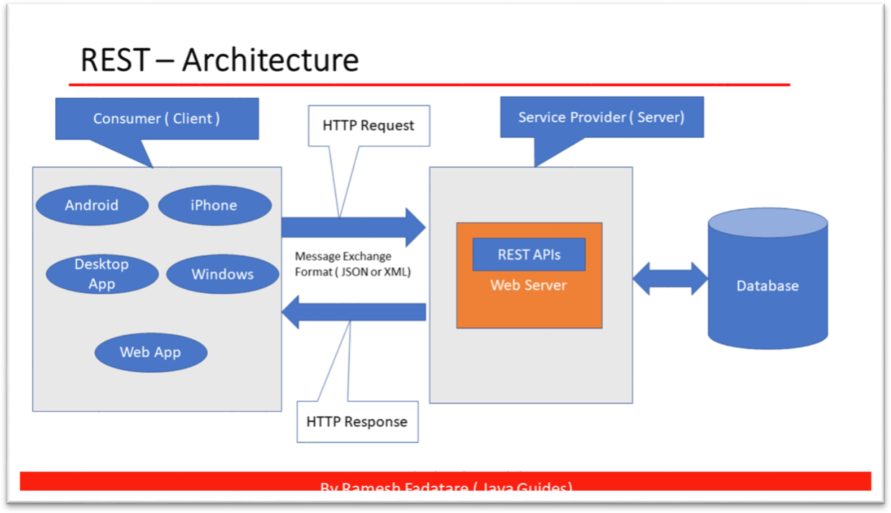

RESOURCE MODELING AND DESIGN
Example resource schema (document service):

    - User: id, name, email, createdAt
    - Document: id, ownerId, filename, contentType, size, uploadedAt, metadata

Modeling relationships and access patterns early helps design efficient endpoints and authorization rules.

PROPOSAL DOCUMENT STRUCTURE
A professional API proposal includes:

    - Executive summary and objectives.
    - Resource definitions and relationships.
    - Endpoint list with method, path, headers, sample request, and response.
    - Error code matrix and examples.
    - Non-functional requirements (size limits, expected throughput).

SAMPLE PROPOSAL (EXCERPT)
Endpoint: POST /documents
Purpose: Upload a document and persist metadata.
Request (multipart/form-data): file (binary), metadata (JSON)
Response (201): { "id": "doc_123", "filename": "resume.pdf", "ownerId": "user_12", "uploadedAt": "2025-07-31T12:00:00Z" }

MODULE 2: BUILD A BASIC RESTFUL WEB SERVICE

PROJECT STRUCTURE AND SETUP
Recommended layout (Express.js):

project-root/
├─ package.json
├─ src/
│ ├─ index.js
│ ├─ routes/
│ ├─ controllers/
│ ├─ services/
│ ├─ middleware/
│ └─ utils/
└─ tests/

DETAILED IMPLEMENTATION (CODE SNIPPETS & EXPLANATION)
Route example:

// src/routes/documents.js
const express = require('express'); const router = express.Router();
const uploadController = require('../controllers/documents'); router.post('/', uploadController.handleUpload); router.get('/:id', uploadController.handleDownload); module.exports = router;

Controller responsibilities: validate input, call service layer, format response, log errors.

ERROR HANDLING AND VALIDATION
    - Use express-validator for request validation.
    - Centralized error middleware returns { error: { code, message, details } }.
    - Use semantic HTTP codes (400, 401, 403, 404, 413, 500).

DEPLOYMENT NOTES
For demonstration, the prototype can be deployed to Render or Heroku. Production-ready deployment requires Docker, a reverse proxy (NGINX), monitoring (Prometheus/Grafana), and object storage for assets.

MODULE 3: IMPLEMENT THE ABILITY TO UPLOAD DATA

FILE UPLOAD ARCHITECTURE
Handle multipart uploads with streaming to avoid memory pressure. Middleware (e.g., multer) should write to disk or pipe directly to cloud storage for large files.

Table 8.1 — FILE UPLOAD VALIDATION RULES

Rule ID
Validation Action on Fail

R1 Allowed MIME types (application/pdf, image/png, image/jpeg)
Reject 400

R2 Max size 10 MB Reject 413
R3 Filename sanitization Clean or Reject 400

SECURITY AND VALIDATION STRATEGIES
    - Validate MIME type and file signatures where possible.
    - Sanitize filenames to prevent directory traversal.
    - Enforce max file size and rate limiting.
    - Consider virus scanning in production.

STORAGE STRATEGIES (LOCAL VS CLOUD)
    - Local storage: Suitable for prototypes and testing.
    - Cloud Storage (S3): Use pre-signed URLs for efficient direct-to-cloud uploads and to offload bandwidth from API servers.

PERFORMANCE CONSIDERATIONS
    - Stream uploads, use pooled connections to storage, and serve static files through a CDN.

Results and Analysis
The successful completion of all four modules demonstrated:

  - Practical proficiency in designing and building RESTful services.
  - Hands-on exposure to real-world engineering practices.
  - Strengthened problem-solving and debugging skills.
  - Increased confidence in applying software engineering principles.

The program effectively simulated industry tasks and offered a platform for skill development beyond academic study.

Conclusion and Reflections
The Software Engineering Job Simulation was an enriching experience that bridged the gap between theoretical knowledge and practical application. I not only learned technical concepts but also developed professional skills such as documentation, modular coding, and test-driven development.

The tasks mirrored real workplace scenarios, preparing me for future challenges in backend development. This experience reinforced the importance of planning, implementing, and testing in software engineering, shaping me into a more well-rounded professional.

References
  - Fielding, R. (2000). Architectural Styles and the Design of Network-based Software Architectures. University of California, Irvine.
  - REST API Design Guide, Microsoft Docs.
  - Flask and Django Documentation (Python).
  - Express.js Documentation (Node.js).
  - JUnit and PyTest Testing Framework Documentation.

